Making a Website with Wix

For our next assignment you will be creating a website through wix.com. To begin, go to www.wix.com, click on “start now,” “create a new account,” and enter your email and password.

Once you’re logged in, click “create” at the top. On the left, select “new” or “most popular” and pick a template you like. Click “Edit” and begin!

Wix is pretty easy to figure out (just drag and drop anything you want) and put it wherever you want it on your page. Make sure you SAVE often. Also make sure you’re using Google Chrome, not Internet Explorer.

NO COPYING AND PASTING! Everything must be in your own words

Your website will be about a Country. Pick a Country that you want to visit and learn more about.

Your Site Must Include:

A Home Page (10 points)
-Basic info about the country (6 sentences)
-A map/picture of the country
-Links to all other pages

5 Additional Pages (So 6 pages total) (10 points each)
-Links to all other pages
-At least 8 sentences of text on each page (correct spelling and grammar)
-At least one widget, song, video, or photo gallery

Total: 60 Points
Ideas for the pages:

-History -Economy -Food -Music -Sites to visit -Sports

[ Example on the next page ]
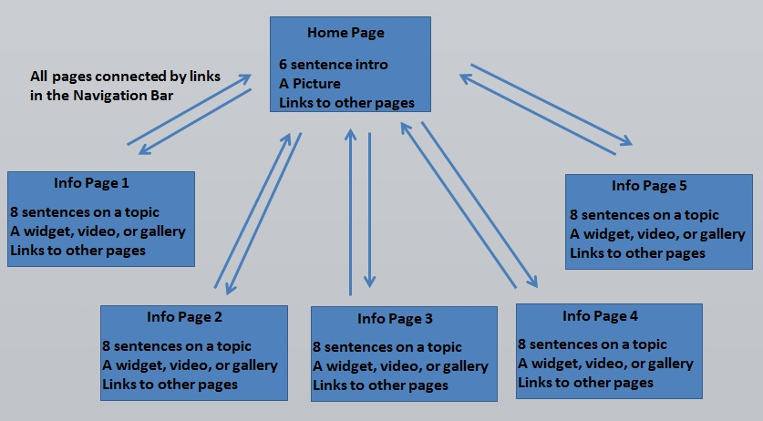
Sample Layout

